NOVEL BIO-POLYMERS FOR ….

R. Hrdina¹ and J. Smith²

¹Faculty of Chemical Technology, University of Pardubice
Studentská 95, 532 10 Pardubice, Czech Republic, radim.hrdina@upce.cz
²University of …………………………………

Abstract: The purpose of the paper is to describe …………………………………………………..
…………………………………………………………………………………………………………………………………………………………………………………………………………………………………………………………………………………………………………………………………………………………………………………………………………………………………………………………………………………………………………………………………………………………………………………………………..
Key Words: hyaluronan, chitin, ………………………

- INTRODUCTION

Novel bio-polymers such as hyaluronic acid, chitin and chitosan have been intensively investigated for medicinal and cosmetic purposes [1, 2].
…….
………

- EXPERIMENTAL

Prepared fibres (Fig. 1) were …………………………………………………………………...

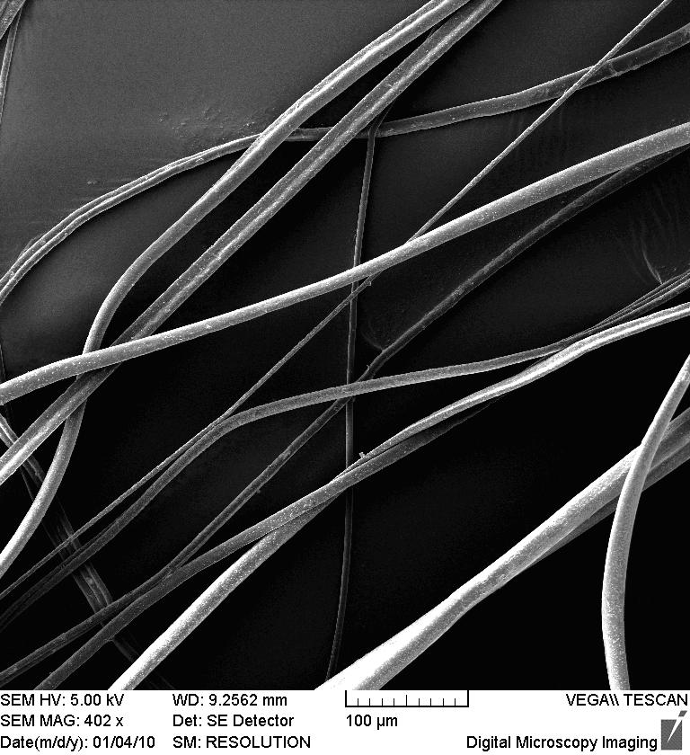

Figure 1 EMS of prepared fibres

For computer aided design purposes is essential to calculate……………………………….
……………………………………………………………………
………………………………………………………………………..
General Minkowski distance (metric) is given by relation:

$$d_{\text{Mj}}=\sqrt[p]{\sum_{i=1}^{m}{(G_{i}−R_{\text{ij}})^{p}}}$$ | (1)

where for p=1 it is …………………………………………………………………………………..
………………………………………………………………………………………………………
……………………………………….

- RESULTS AND DISCUSSION

Reaction conditions (Tab. 1) were ……………..
………………….

Table 1 Reaction conditions

Entry | Temperature (ºC) | Yield (%) | Remark
1 | 80 | 65
2

Incorporation of silver into fibre (Scheme 1) was ………………
………………………….
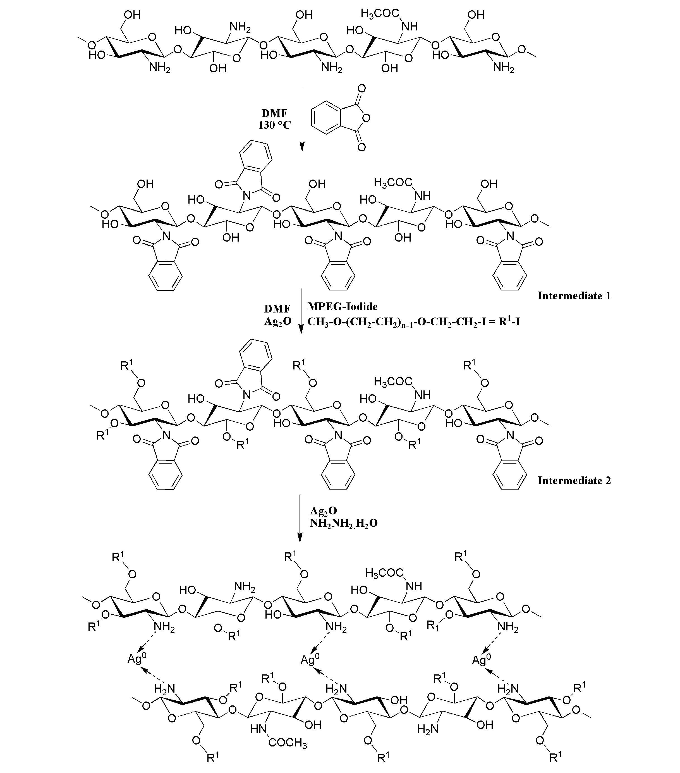

Scheme 1 Reaction of ……………

……………………………………
……………………………………..

- CONCLUSIONS

Evidently expressing …………………………………………………………………………………….
……………………………………………………………………………………………………………..

Acknowledgements: This work was supported by the research project ………

- REFERENCES

- Burgert L., Hrdina R., Masek D., Velebny V.: PCT Int. Appl. (2012), WO 2012089179 A1 20120705
- Abdel-Mohsen A. M., Hrdina R., Burgert L., Krylova G., Abdel-Rahman R. M., Krejcova A., Steinhart M., Benes L.: Carbohydrate Polymers 89(2), 411-422, 2012
- Černý M., Gluckhaufová D., Toms M.: Methods for Complex Evaluation of Variants, Academia Praha 1980 (in Czech)

